# Triples authored for the concept topic: iLO remote console

The iLO remote console can be used to remotely access the graphical display, keyboard, and mouse of the host server.

The remote console provides access to the remote file system and network drives. With remote console access, you can observe POST messages as the server starts, and initiate ROM-based setup activities to configure the server hardware.

When you install an OS remotely, the remote console enables you to view and control the host server monitor throughout the installation process.

**Triples authored by Shrihari:**

* iLO remote console is used to access host server.
* Host server contains graphical display.
* Host server contains keyboard.
* Host server contains mouse.
* Remote console provides user access to remote file system and network drives.
* User can observe POST messages.
* User can initiate ROM-based setup activities.
* ROM-based setup activities is used to configure server hardware.
* User can install OS remotely.
* Remote OS gives access to remote console. 🡪 wrong; right version 🡪 Remote console gives access to remote OS
* Remote console enables user to view and control the host server monitor.

**KG Score – 8.6/10**

**KG Graph:**

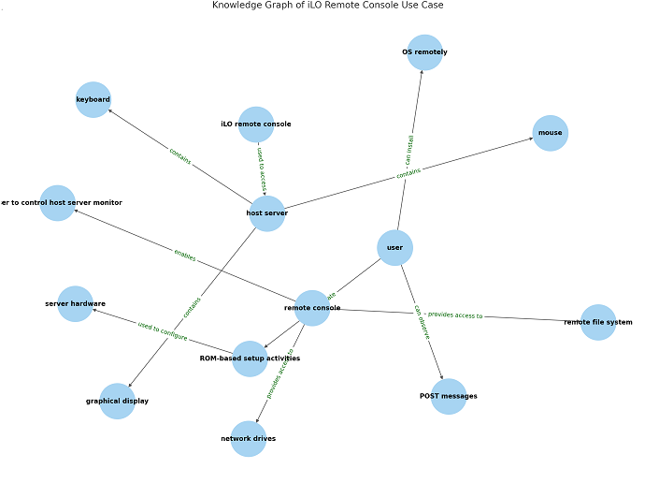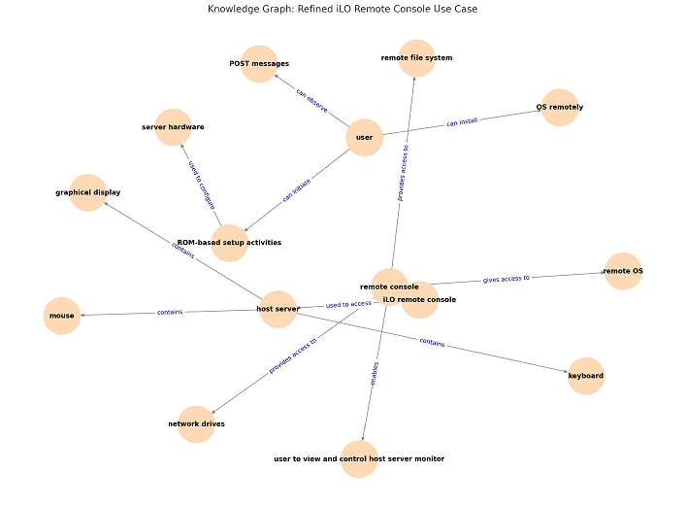

**Triples generated by AI:  
• iLO remote console — can be used to access — graphical display of the host server**

**• iLO remote console — can be used to access — keyboard of the host server**

**• iLO remote console — can be used to access — mouse of the host server**

**• iLO remote console — provides access to — remote file system**

**• iLO remote console — provides access to — network drives**

**• Remote console access — allows you to observe — POST messages during server startup**

**• Remote console access — allows you to initiate — ROM-based setup activities**

**• ROM-based setup activities — are used to configure — server hardware**

**• Remote console — enables viewing and control of — host server monitor during OS installation**

**KG Score: 9.4**

**Graph:**

